NT Conradie

24/01/2020

MEng Safety Report

Tensile and Compression Testing of

Hyperelastic Materials

**Date:** January 2020

**Supervisor:** Dr MP Venter

**Student:** Mr NT Conradie

**Laboratory Technician:** Mr N Macallister

# Emergency Contacts:

|  |  |  |  |
| --- | --- | --- | --- |
| **Contact** | **Room nr.** | **Work nr.** | **Cell nr.** |
| Mr Ferdi Zietsman | M | 4954 | 0832331646 |
| Dr MP Venter | M3040 | 4477 | 0828660836 |
| Campus Security | - | 0218082333 | 0828082333 (WhatsApp) |
| Fire Brigade | - | 0218088888 | - |
| Ambulance | - | 0218833444 | - |

**Pressure Vessels or Pipes:** No pressure vessel or pipe with a pressure

in excess of 50 kPa is involved in this project.

Laboratory Technician (Mr N Macallister)

Supervisor (Dr MP Venter)

Laboratory Manager (Mr Cobus Zietsman)

# Overview of Testing

Tensile and compressive testing of Ecoflex 0030, Mold Star 15 and Smooth-Sil 950 is to be performed according to ISO 37 and ISO 7743 standards respectively.

Specimens of each of the materials are prepared in the laboratory by mixing the required two constituent components in accurately measured appropriate amounts. The materials are poured into cleaned and prepared moulds. The filled moulds are inserted in the degasser to remove any air bubbles formed during mixing and pouring. Once this is completed, any excess material is removed from the filled moulds. The filled moulds are left to set overnight. The workstation and equipment are cleaned appropriately for further use.

Once the specimens have set, they are removed from the moulds. The moulds are cleaned appropriately for further use. The specimens are then sprayed with spray paint to produce an appropriately distributed speckled pattern on the specimen surface for the DIC test.

For tensile testing, the MTS crosshead and load cell are set up appropriately, as is the workstation according to the instruction booklet. Tensile grips are fixed to the MTS frame. The specimen is placed in the grips and the extensometer is fixed to the specimen. The DIC equipment is set up so that the specimen is appropriately lit and in focus. Testing is commenced and the extensometer removed when appropriate. Once the specimen has failed, it is removed from the grips. All data recorded is backed up appropriately.

The procedure for compressive testing is much the same as detailed above, barring that compressive grips are fixed to the frame and the test is set up for compressive testing.

Once a testing session is completed, all relevant equipment is carefully stowed away as needed.

The equipment that will be used is detailed in the table below.

|  |
| --- |
| **Equipment** |
| Degasser |
| MTS tension/compression load frame fitted with load cell |
| MTS standard tensile grips |
| MTS standard compressive grips |
| MTS extensometer |
| DIC adjustable tripod frame |
| DIC processor |
| 2 DIC cameras |
| 2 DIC constant light sources |
| Spray paint canister |

Samples to be tested are detailed in the table below.

|  |  |  |  |
| --- | --- | --- | --- |
| **Material** | **Test** | **Number of samples** | **Thickness (mm)** |
| Ecoflex 0030 | Tensile | 15 | 2 |
| Ecoflex 0030 | Compressive | 15 | 12 |
| Mold Star 15 | Tensile | 15 | 2 |
| Mold Star 15 | Compressive | 15 | 12 |
| Smooth-Sil 950 | Tensile | 15 | 2 |
| Smooth-Sil 950 | Compressive | 15 | 12 |

Tensile and compressive test specimen examples are shown in the figures below.

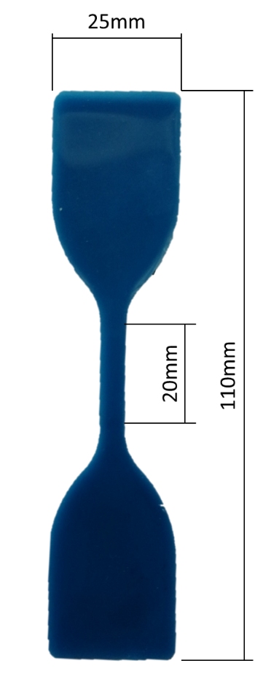

Figure - Tensile Test Specimen

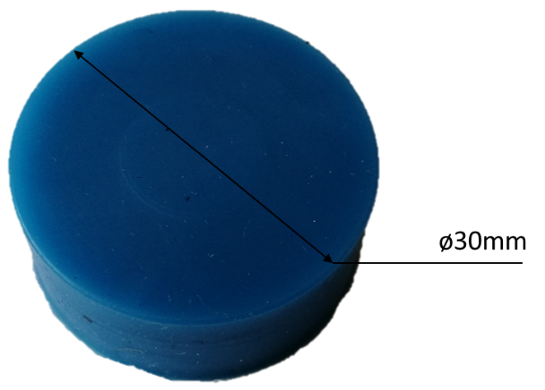

Figure - Compressive Test Specimen

The estimated maximum loads are detailed in the table below.

|  |  |
| --- | --- |
| **Test** | **Estimated maximum load (N)** |
| Tensile | 15 |
| Compressive | 100 |

# General Lab Safety

* Laboratory induction is required before any testing may take place
* Obtain and work through the safety instructions for any laboratory setup before using it, or compile new ones if it does not exist
* An approved safety report is required to work in the laboratory and must be visible and accessible at all times during testing
* Always ensure at least one other person is within earshot when working in the laboratory
* Unsupervised testing after working hours is not allowed without proper approval
* Closed shoes are required to be worn at all times in the laboratory area
* No loose clothing may be worn in the laboratory area
* No earphones or headsets are allowed when working in the laboratory area so that any alarms may be heard properly
* No food or drinks are permitted within the laboratory area
* Cellphones may not be used when working with laboratory equipment
* No unauthorised persons are allowed within the laboratory area
* General good working practices should be held to
* Extra caution should be taken when working in the DIC laboratory and with DIC equipment, as the equipment is highly sensitive and may not be violently disturbed
* Help should be requested if uncertain, it will be willingly provided
* Report any safety risks observed to the lab technician or a relevant member of staff, or campus security if observed after hours
* Report any incident in which a significant injury has occurred immediately to the lab technician or a relevant member of staff
* If a fatal or potentially fatal injury has occurred, the law specifies that the site must not be disturbed
* In case of loadshedding occurring during testing:
  + Treat all electrical outlets as live
  + Ensure all plugs are switched off
  + Unplug equipment as necessary

# Fire Safety

There is no direct fire risk associated with the work as detailed in this report.

In the case of an emergency, the evacuation route for the laboratory may be found in Appendix A.

* Avoid the internal combustion engine laboratory if the fire alarm has sounded, as the automatic fire extinguishers may lead to suffocation.
* If you are the last to leave an area, close the door behind you and tie something to the handle.

# Activity Based Risk Assessment

|  |  |  |  |  |
| --- | --- | --- | --- | --- |
| **Activity** | **Risk** | **Risk type** | **Classification of risk severity** | **Mitigating steps** |
| Entering the lab | Injuring yourself due to improper use of the door | P | Acceptable Risk | Be cautious and aware of your surroundings |
| Moving around the laboratory | Tripping and falling over equipment | P&E | Possible risk | Be cautious and aware of your surroundings |
| Switching on lights | Shocking yourself | P | Acceptable Risk | Inspect the switch before using it for signs of damage |
| Setting up for the mixing process | Injuring yourself | P | Acceptable Risk | Be cautious and aware of your surroundings |
| Dropping materials and equipment | E | Acceptable Risk | Be careful when handling materials and equipment |
| Preparing specimens | Improper procedures resulting in contaminated or unusable specimens | E | Possible risk | Make sure to exactly follow preparation instructions and be careful |
| Degassing specimens | Improper use of the degasser | P&E | Substantial risk | Inspect the degasser before use and make sure to exactly follow instructions for use |
| Equipment failure | P&E | Possible risk | Inspect the degasser for any signs of damage before use |
| Moving DIC equipment from storage to the appropriate position | Damaging equipment | E | Acceptable Risk | Be careful when moving equipment |
| Turning on equipment | Electrical shock | P | Possible risk | Check all cabling before plugging in or switching on to ensure the insulation is intact |
| Creating new test methods | Overwriting the test method templates | E | Acceptable Risk | Follow instructions carefully and be aware when saving the new test methods |
| Manually adjusting the crosshead height | Injuring yourself | P | Substantial risk | Keep clear of the crush zone between the crosshead and load frame when making adjustments |
| Compressing the load cell above its limits | E | Substantial risk | Always check that the hard-limits are set correctly before commencing testing, and turn off the handset to avoid accidental adjustment |
| Changing grips | Hand injuries from tool misuse | P | Substantial risk | Correctly use tools, do not use excessive force and be cautious |
| Dropping a grip | P&E | Substantial risk | Always wear closed shoes in the laboratory, hold grips firmly and carefully, and be cautious |
| Fitting the sample | Finger injuries | P | Substantial risk | Use fine adjustment and be cautious |
| Overtightening the grips | E | Substantial risk | Do not force the grips once they are tightened appropriately |
| Fitting the extensometer | Dropping the extensometer | P | Acceptable Risk | Be careful and attach the extensometer to the MTS frame to prevent it from falling to the ground |
| Applying a tensile load to the sample | Compressing the load cell | E | Possible risk | Verify the crosshead direction is correct before commencing testing |
| Overloading the load cell and grips | E | Possible risk | Ensure the load limits are set to +25000N and -400N before commencing testing |
| Capturing relevant data | Overextending the extensometer | E | Substantial risk | Remove the extensometer before its maximum extension has been reached |
| Extensometer failure due to sample failure | E | Substantial risk | Remove the extensometer before sample failure |
| Failing to capture data | E | Acceptable Risk | Check that all recording equipment is properly set up before commencing testing |
| Removing the extensometer | Dropping the extensometer | E | Possible risk | Be careful and place the extensometer on a safe area |
| Removing the specimen | Finger injuries | P | Substantial risk | Ensure the crosshead is stationary and will not be activated before removing the specimen |
| Returning the crosshead | Bodily injuries | P | Substantial risk | Be careful and ensure you are standing away from the MTS frame when returning the crosshead |
| Removing the grips | Hand injuries from tool misuse | P | Substantial risk | Correctly use tools, do not use excessive force and be cautious |
| Dropping a grip | P&E | Substantial risk | Always wear closed shoes in the laboratory, hold grips firmly and carefully, and be cautious |
| Backing up recorded data | Loss of data | P&E | Possible risk | Store data according to guidelines and keep sufficient independent backups |
| Turning off equipment | Electrical shock | P | Possible risk | Check all cabling before switching off or plugging out to ensure insulation is intact |
| Tidying the workstation | Tripping and falling over equipment | P&E | Possible risk | Be cautious and aware of your surroundings |
| Locking the laboratory | Injuring yourself due to improper use of the door | P | Acceptable Risk | Be cautious and aware of your surroundings |
| Returning the key | Losing the key | E | Possible risk | Be careful when handling the key and be conscious of its whereabouts until it has been handed over to the appropriate personnel |

# Appendix A – Emergency Evacuation Plan

